Food Inspection Equipment

In order to conduct risk-based inspections inspectors must be provided with the proper equipment to assess the control of foodborne illness risk factors within food establishments.
At a minimum, EACH inspector should be provided with the following essential equipment:
(1) Inspection Form
(2) Cellphone
(3) Thermometer with appropriate probes for food being tested
(4) Alcohol swabs or other suitable equipment for sanitizing thermometer probes
(5) Chemical test kits for different chemical sanitizer types (Sanitizer Indicator Papers)
(6) Flashlight
(7) Clip Board
(8) Note Pad
(9) Pen (Black)
(10) Pencil
Other equipment may be provided to inspectors on an “as needed” basis. While it is desirable for each inspector to have the following equipment, depending on the resources available to the agency, this equipment may be shared in a central office as appropriate.
(1) Black light
(1) Light meter
(2) Measuring device for measuring distance
(3) Time/Temperature data logger
(4) pH meter
(5) Water activity meter
(7) Foodborne illness investigation kits
(8) Sample collection kits
(9) Pressure gauge for determining in-line pressure of hot water at injection point of ware washing machine (5-30psi)
Temperature-measuring instruments

Bimetal Thermometer. The 0F to 212F range, 1” dial, 5” stem bimetal dial thermometer remains the handiest and probably our most versatile inspection tool.

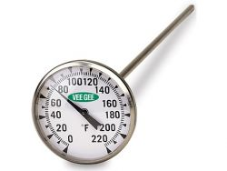

Thermocouple Thermometer. For critical temperature measurements, the needle-probe thermocouple thermometer is our mainstay in conducting foodservice inspections, and for good reason: it is convenient, fast and accurate.

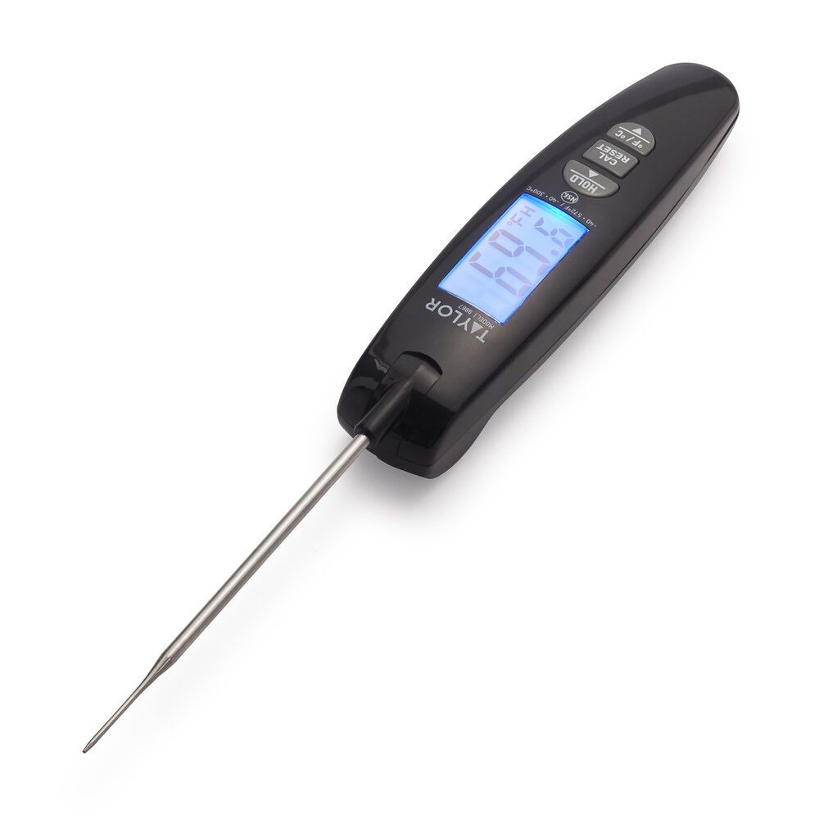

Infrared Thermometer. Screening tool and can only measure surface temperature.
